[How do I import JavaFX into Eclipse?](https://stackoverflow.com/questions/33819052/how-do-i-import-javafx-into-eclipse)

**1st Step**

**Install javafx plugin**

1. Open Eclipse -> Help -> Eclipse Marketplace
2. Search for "javafx"
3. You'll see e(fx)eclipse, install it.
4. After installation, restart eclipse

**OR**

1. Open Eclipse -> Help -> Install new software
2. Select the highlighted link

1. Check these two boxes and install it

1. After installation, restart eclipse

**2nd Step**

**Download JavaFX SDK**

1. Download JavaFX in here <https://openjfx.io/openjfx-docs/>
2. JavaFX and Eclipse -> Non-modular from IDE

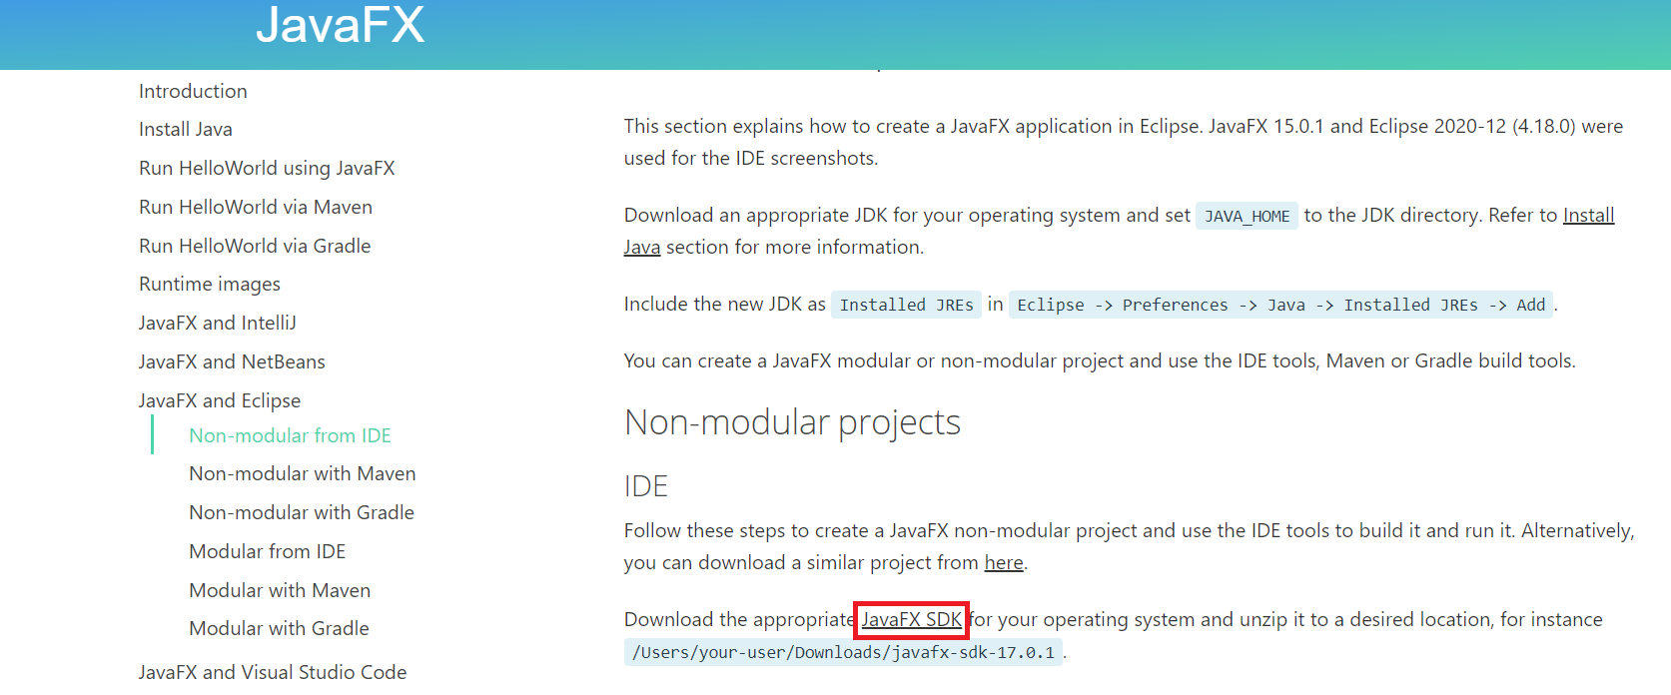

Click on this highlighted link

1. Extract the folder and place it downloads folder (or anyplace)

**3rd Step**

**Create new javafx project**

1. Then create new project File > New > Project(don't select Java project).
2. Then Select JavaFX > JavaFX Project
3. Then click Next, give project name and click Finish
4. You'll get "The import javafx cannot be resolved"

**4th Step**

**Add User Library**

1. Then in eclipse click the Windows and select preferences ->java->Build Path->User Libraries
2. Inside User Libraries -> click new ->save with any name e.g., javafx
3. Click on Add External JARs from the right
4. Then from the download JavaFX (placed in downloads folder or somewhere you've placed).
5. Choose all the .jars file in Downloads/javafx-sdk-11.0.2/lib/(all .jar(s) file) and click open.
6. Then click Apply and Apply and close.

**5th Step**

**Add Lib and configure class path**

right-clicking on the javaFX project folder-> Build Path-> Add libraries-> User Library->select javafx(or any name that you just added with JAR files)-> Next and Finish

again right-clicking on the javaFX project folder-> Build Path-> Configure Build Path->Module Path -> Select JavaFX SDK-> Remove library-> Select classpath -> add library-> user library-> select library-> apply.

**6th Step**

**Add VM arguments**

1. Then right click on project > Run as > Run configuration
2. Choose the arguments tab and type this in VM arguments.
3. Copy the following line with the path of your JAR lib

--module-path "C:\Users\Nida\Downloads\openjfx-17.0.2_windows-x64_bin-sdk\javafx-sdk-17.0.2\lib" --add-modules javafx.controls,javafx.fxml

1. (Important) Then uncheck the box that says "Use the -XstartOnFirstThread..."
2. Click Apply and Run.

**Run the project**

Click Run -> Run As -> Java Application -> Main - hellofx to run the project.

**Successfully executed**